Report for ForestQuery into Global Deforestation, 1990 to 2016

ForestQuery is on a mission to combat deforestation around the world and to raise awareness about this topic and its impact on the environment. The data analysis team at ForestQuery has obtained data from the World Bank that includes forest area and total land area by country and year from 1990 to 2016, as well as a table of countries and the regions to which they belong.

The data analysis team has used SQL to bring these tables together and to query them in an effort to find areas of concern as well as areas that present an opportunity to learn from successes.

## 1. **GLOBAL SITUATION**

According to the World Bank, the total forest area of the world was 41282694.9 in 1990. As of 2016, the most recent year for which data was available, that number had fallen to39958245.9, a loss of 1324449 km ^2, or 3.20824258980244%.

The forest area lost over this time period is slightly more than the entire land area of Peru listed for the year 2016 (which is 1279999.98911 km^2).

## 2. **REGIONAL OUTLOOK**

In 2016, the percent of the total land area of the world designated as forest was 31.38 %. The region with the highest relative forestation was Latin America & Caribbean, with 46.16%, and the region with the lowest relative forestation was Middle East & North Africa, with 2,07% forestation.

In 1990, the percent of the total land area of the world designated as forest was 32.42%. The region with the highest relative forestation was Latin America & Caribbean, with 51.03%, and the region with the lowest relative forestation Middle East & North Africa, with 1,78% forestation.

Table 2.1: Percent Forest Area by Region, 1990 & 2016:

|  |  |  |
| --- | --- | --- |
| **Region** | **1990 Forest Percentage** | **2016 Forest Percentage** |
| Latin America & Caribbean | 51.03 | 46.16 |
| Europe & Central Asia | 37.28 | 38.04 |
| North America | 35.65 | 36.04 |
| World | 32.42 | 31.38 |
| Sub-Saharan Africa | 30.67 | 28.79 |
| East Asia & Pacific | 25.78 | 26.36 |
| South Asia | 16.51 | 17.51 |
| Middle East & North Africa | 1.78 | 2.07 |

The only regions of the world that decreased in percent forest area from 1990 to 2016 were Latin America & Caribbean (dropped from 51,03% to 46,16 %) and Sub-Saharan Africa (from 30,67% to 28,79%). All other regions actually increased in forest area over this time period. However, the drop in forest area in the two aforementioned regions was so large, the percent forest area of the world decreased over this time period from 32.42% to 31.38%.

## 3. **COUNTRY-LEVEL DETAIL**

### SUCCESS STORIES

There is one particularly bright spot in the data at the country level, China. This country actually increased in forest area from 1990 to 2016 by 527229.062. It would be interesting to study what has changed in this country over this time to drive this figure in the data higher. The country with the next largest increase in forest area from 1990 to 2016 was the United States, but it only saw an increase of 79200, much lower than the figure for China.

China and the United States are of course very large countries in total land area, so when we look at the largest *percent* change in forest area from 1990 to 2016, we aren’t surprised to find a much smaller country listed at the top. Iceland increased in forest area by 213,66 % from 1990 to 2016.

### LARGEST CONCERNS

Which countries are seeing deforestation to the largest degree? We can answer this question in two ways. First, we can look at the absolute square kilometer decrease in forest area from 1990 to 2016. The following 3 countries had the largest decrease in forest area over the time period under consideration:

Table 3.1: Top 5 Amount Decrease in Forest Area by Country, 1990 & 2016:

|  |  |  |
| --- | --- | --- |
| Country | Region | Absolute Forest Area Change |
| Brazil | Latin America & Caribbean | -541510 |
| Indonesia | East Asia & Pacific | -282193.9844 |
| Myanmar | East Asia & Pacific | -107234.0039 |
| Nigeria | Sub-Saharan Africa | -106506.00098 |
| Tanzania | Sub-Saharan Africa | -102320 |

The second way to consider which countries are of concern is to analyze the data by percent decrease.

Table 3.2: Top 5 Percent Decrease in Forest Area by Country, 1990 & 2016:

|  |  |  |
| --- | --- | --- |
| Country | Region | Pct Forest Area Change |
| Togo | Sub-Saharan Africa | -75.45 |
| Nigeria | Sub-Saharan Africa | -61.80 |
| Uganda | Sub-Saharan Africa | -59.27 |
| Mauritania | Sub-Saharan Africa | -46.75 |
| Honduras | Latin America & Caribbean | -45.03 |

When we consider countries that decreased in forest area the most between 1990 and 2016, we find that four of the top 5 countries on the list are in the region of Sub-Saharan Africa. The countries are Togo, Nigeria, Uganda, and Mauritania. The 5th country on the list is Honduras, which is in the Latin America&Caribbean region.

From the above analysis, we see that Nigeria is the only country that ranks in the top 5 both in terms of absolute square kilometer decrease in forest as well as percent decrease in forest area from 1990 to 2016. Therefore, this country has a significant opportunity ahead to stop the decline and hopefully spearhead remedial efforts.

### QUARTILES

Table 3.3: Count of Countries Grouped by Forestation Percent Quartiles, 2016:

|  |  |
| --- | --- |
| Quartile | Number of Countries |
| 75-100 | 9 |
| 50-75 | 38 |
| 25-50 | 72 |
| 0-25 | 85 |

The largest number of countries in 2016 were found in the 0-25% quartile.

There were 85 countries in the top quartile in 2016. These are countries with a very high percentage of their land area designated as forest. The following is a list of countries and their respective forest land, denoted as a percentage.

Table 3.4: Top Quartile Countries, 2016:

|  |  |  |
| --- | --- | --- |
| Country | Region | Pct Designated as Forest |
| Suriname | Latin America & Caribbean | 98.26 |
| Micronesia, Fed. Sts. | East Asia & Pacific | 91.86 |
| Gabon | Sub-Saharan Africa | 90.04 |
| Seychelles | Sub-Saharan Africa | 88.41 |
| Palau | East Asia & Pacific | 87.61 |
| American Samoa | East Asia & Pacific | 87.50 |
| Guyana | Latin America & Caribbean | 83.90 |
| Lao PDR | East Asia & Pacific | 82.11 |
| Solomon Islands | East Asia & Pacific | 77.86 |

## 5. RECOMMENDATIONS

*Write out a set of recommendations as an analyst on the ForestQuery team.*

* *What have you learned from the World Bank data?*
* *Which countries should we focus on over others?*

*According to the analysis which I have made, the total forest area decreased from 1990 to 2016, the percent of 3,2 % may seem to be small, but in km^2 it’s a lot –* 1 324 449 km ^2.

By the way we have a country with well-managed ecological problems- China, despite being a country with high-volume production every year. Other countries should take seriously its experience.

It need to be mentioned that mostly small countries (its land in km ^2) have a high percent of forest occupation, they try to preserve their nature.

By the way more your economy is developed, more ecological problems you have to solve. As our resources are not endless we need to develop new way of preserving our forests, or inventing new technologies to save our planet for our children.

APPENDIX (SCREENSHOTES FROM ATOM where I have saved it)

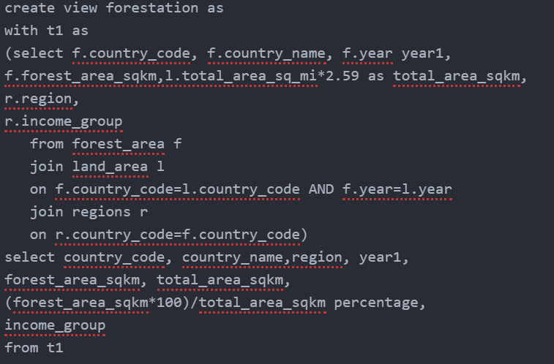

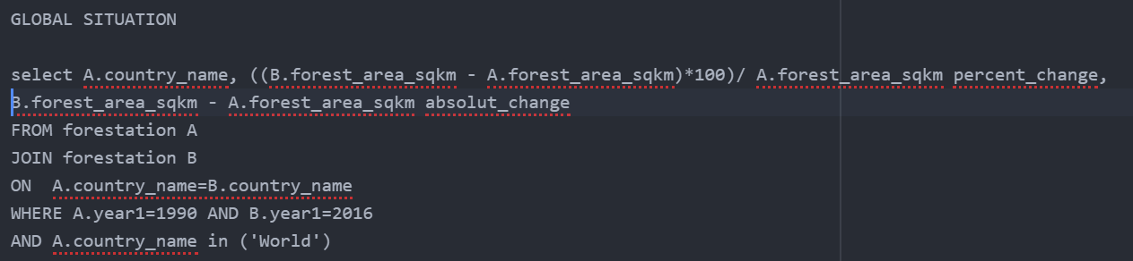

| **year1** | **sum** | **previous_year** | **year_diff** | **perc_diff** |
| --- | --- | --- | --- | --- |
| 1990 | 41282694.9 |  |  |  |
| 2016 | 39958245.9 | 41282694.9 | -1324449 | -3.20824258980244 |

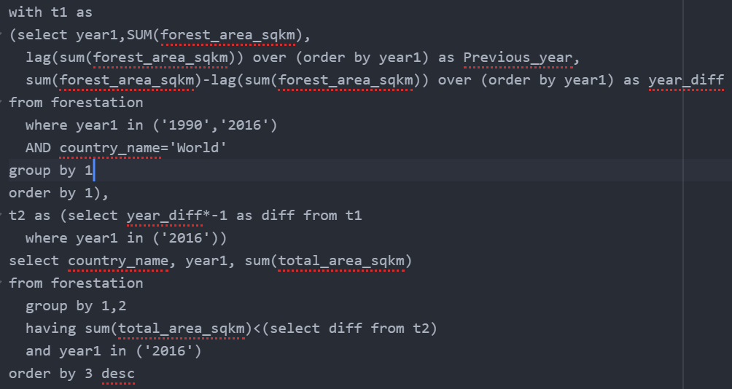

| **country_name** | **year1** | **sum** |
| --- | --- | --- |
| Peru | 2016 | 1279999.9891 |

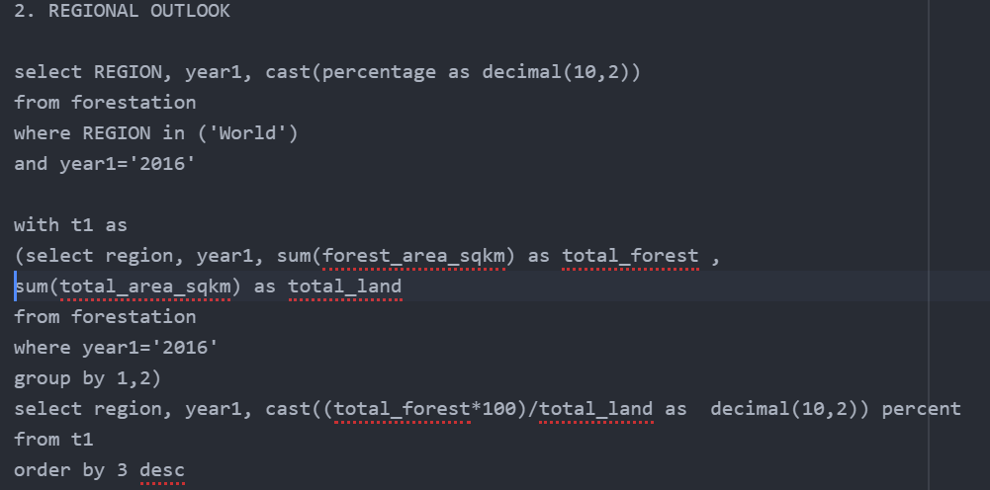

| **region** | **year1** | **percentage** |
| --- | --- | --- |
| World | 2016 | 31.38 |

| **region** | **year1** | **percent** |
| --- | --- | --- |
| Latin America & Caribbean | 2016 | 46.16 |
| Middle East & North Africa | 2016 | 2.07 |

